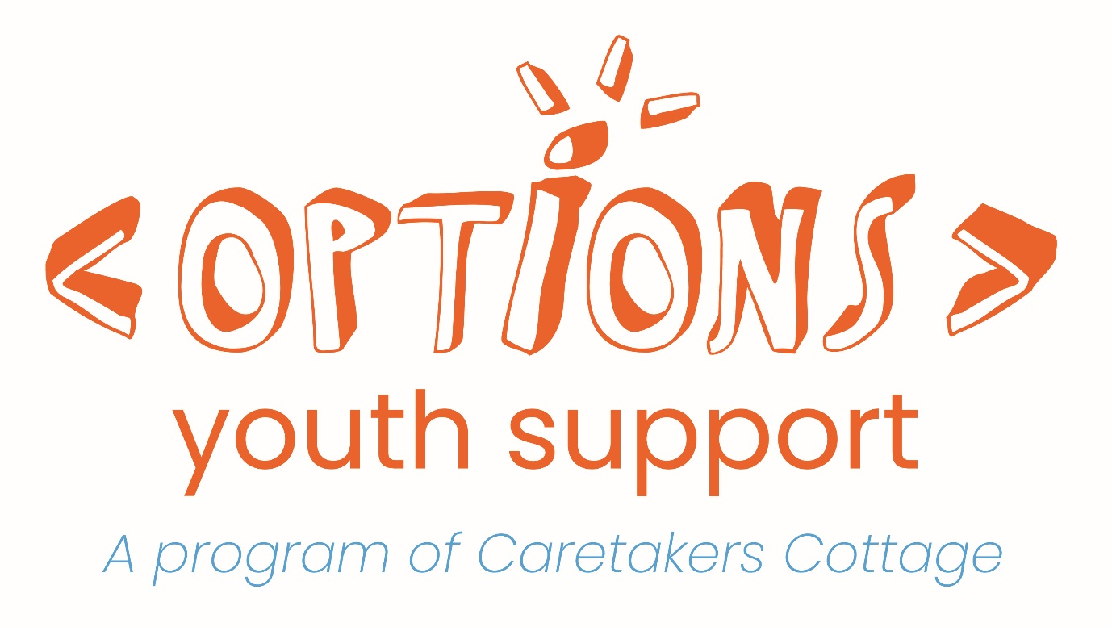

REFERRAL FORM

**DOES THE YOUNG PERSON HAVE SOMEWHERE SAFE TO SLEEP TONIGHT?**

If you or the young person you are supporting require crisis accommodation, please contact Link2Home on **1800 152 152**.

Link2Home is a state-wide information and referral service for people who are homeless or at risk of homelessness. Link2Home provide information, conduct assessments, and make referrals to homelessness services across NSW.

Link2Home is available 24 hours a day, 7 days a week, every day of the year.

**Before making a referral to Options, please read the following information about the Options**

**program to assist you in determining that Options is the right placement for your client.**

The overarching aim of Options Youth Support is to assist young people to build the skills and confidence to live self-sufficiently. Options has a strong focus on working towards independence from the social welfare system.

Options is a voluntary program; young people sign up to the program because they are willing and wanting to engage. Options is the transitional accommodation and support program of Caretakers Cottage. Placements at Options are open to individuals, pregnant young women, families and couples, aged between 16-25 years, in single and shared accommodation.

Options is primarily a support program, not an affordable accommodation or Housing First program.

Tenancies and rent are managed externally by a Community Housing Provider. The timeframe a young person can stay with Options is 18-24 months, dependent upon individual circumstances. An exit plan based around moving out of social welfare and into the rental market is an integral part to the overall case plan. As Options is primarily shared accommodation we cannot house young people who have current or recent alcohol or other drug dependencies or significant mental health concerns which are not being addressed at the time of the referral.

Initially young people are put on a 3-month trial period whereby their suitability for the Options program is assessed for a more permanent placement. Throughout their placement young people will need to pay:

- $85 (21 yrs and under) or $100 (22 yrs and over) per week for rent to the Community Housing Provider

- 3% of the rent amount for water to the Community Housing Provider

- $30 per week for electricity/gas to Options Youth Support

- 100% of household maintenance items (e.g. cleaning products, light globes, groceries)

- On signing the Lease, 2 weeks’ rent

- $100 Security Bond paid to Options upon program sign up

Bedroom furniture is NOT provided- young people need to organise this BEFORE moving in.

PLEASE NOTE: Options cannot move young people’s belongings in or out of the properties. The young person/referring agency will need to organise this themselves. Options has a strict NO PETS rule- this includes dogs, cats, rabbits, guinea pigs, birds, etc.

Does the young person meet the following eligibility criteria? :

ð Has a current, stable income which can be evidenced (i.e. NOT cash in hand)

ð Has an established day plan in place (i.e. ongoing engagement in an activity to address their presenting issues such as education, employment, mental health programs)

ð Requires case work support and accommodation (i.e. not just in need of accommodation)

ð Has an established management plan in place for any mental health and/or drug and alcohol issues

ð Can pay 2 weeks rent + $100 security bond on day of sign up

ð Has bedroom furniture and can move this into the property

If the young person does not meet all the above mentioned criteria, this may indicate they are not ready/suitable for the commitments required of the Options transitional accommodation program.

Feel free to call Options on 9388 9341 and discuss the situation with a case worker before proceeding with the referral.

Options is funded to be a case work support service to young people in need of support and who are open and willing to engage in a collaborative and holistic personal development plan throughout the duration of their time with Options. Options is not simply an affordable accommodation program as there are other services available who meet this need.

For further referral suggestions feel free to call Options on 9388 9341.

Options does not operate on a ‘wait list’ due to the nature and structural set up of our program. Many properties are a share house and therefore the current needs of the share house are taken into consideration when assessing referrals. Referrals are assessed once a week on a Monday morning. Due to the high level of referrals received we cannot get back to every one individually with a response, it is recommended that you call the office on 9388 9341 to follow up the referral outcome. If Options cannot accommodate the young person, we will always offer alternate suggestions for referrals.

*BY PROCEEDING WITH THIS REFERRAL, YOU ACKNOWLEDGE YOU HAVE UNDERSTOOD THE ABOVE CONDITIONS OF OPTIONS AND HAVE CLEARLY CONVEYED THIS TO THE YOUNG PERSON

Please fill in the following with **as much detail as possible** and email back when completed: [optionsyouth@caretakers.org.au](mailto:optionsyouth@caretakers.org.au)

|  |  |  |  |  |  |  |  |  |  |  |  |  |  |  |  |  |
| --- | --- | --- | --- | --- | --- | --- | --- | --- | --- | --- | --- | --- | --- | --- | --- | --- |
| **Referrer’s details** | | | | | | | | | | | | | | | | |
| Today’s date: | | Name: | | | | | | Contact details (ph, email): | | | | | | | | |
| Referring organisation:  Role within organisation:  (if applicable) | | | | | | | | | | | | How long have you know this YP?: | | | | |
| **Young Person’s (YP) details:** | | | | | | | | | | | | | | | | |
| Name: | | | Preferred name: | | | | | | | | | | Mobile/best contact: | | | |
| Are there any contact restriction?  *If so, please provide details* | | | | | | | | | | | | | | | | |
| D.O.B: | | | Gender: | | | | | | | | | | Pronouns: | | | |
| Cultural background?  CALD Aboriginal  Torres Strait Islander None | | | Country of birth: | | | | | | | | | | If NOT born in Australia, what year did they arrive? | | | |
| Main language spoken: | | | Secondary language(s) spoken:  (if applicable) | | | | | | | | | | Does the YP require a translator?  Yes  No | | | |
| Is the YP able to share accommodation?  Yes  No | | | | | | | | | If able to share, are they okay sharing with any gender?  Yes  No (provide detail) ________________________ | | | | | | | |
| Does the young person have any children? Yes  No | | | | | | | | | | | | | | | | |
| **Accommodation information:** | | | | | | | | | | | | | | | | |
| **Reason(s) for seeking support & assistance (please tick all that apply)** | | | | | | | | | | | | | | | | |
| ð Financial difficulties  ð Housing affordability stress  ð Housing crisis  ð Inadequate or inappropriate dwelling conditions  ð Previous accommodation ended  ð Time out from family/other situation  ð Relationship/family breakdown  ð Sexual abuse  ð Domestic and family violence  ð Non-family violence  ð Mental health issues  ð Medical issues  ð Problematic drug or substance use  ð Problematic alcohol use | | | | | ð Employment difficulties  ð Unemployment  ð Problematic gambling  ð Transition from custodial arrangements  ð Transition from foster care and child safety residential placements  ð Transition from other care arrangements  ð Discrimination including racial and sexual  ð Itinerant  ð Unable to return home due to environmental reasons  ð Disengagement with school or other education and training  ð Lack of family and/or community support  ð Other: __________________________  ð Don’t know | | | | | | | | | | | |
| **Main presenting issue (from options above): _____________________________________** | | | | | | | | | | | | | | | | |
| Has the client had an episode of homelessness in the last **month**?  ð Sleeping rough or in non-conventional accommodation  ð Short-term or emergency accommodation, due to a lack of other options  ð Not homeless  ð Don’t know | | | | | | | | | Has the client had an episode of homelessness in the last **12 months**?  ð Sleeping rough or in non-conventional accommodation  ð Short-term or emergency accommodation, due to a lack of other options  ð Not homeless  ð Don’t know | | | | | | | |
| Time since YP’s last permanent place to live:  ð Less than 1 week ago  ð 1 week – 1 month ago  ð More than 1 month – 6 months ago  ð More than 6 months – 1 year ago  ð More than 1 year – 5 years ago  ð More than 5 years ago  ð Don’t know  ð Not applicable  **State and Suburb** of YP’s last permanent place to live: __________________________ | | | | | | | | Where was the YP staying last week?    **State: ________________**    **Suburb**: **_______________**    **Accommodation type:**  **______________________**    **With who: ____________** | | | | | | If different again, please provide details of where they are currently staying:  **State: ________________**    **Suburb**: **_______________**    **Accommodation type:**  **______________________**    **With who: ____________** | | |
| Is the young person **currently paying rent**? Yes  No  If yes, **how much** rent are they paying per fortnight?:______________  If yes, **who** are they paying rent to? Transitional housing provider Public housing provider Private rent Boarding house Emergency accommodation provider Family/friends  Other *(provide details)* | | | | | | | | | | | | | | | | |
| Does the young person have a Housing NSW T number? Yes  No  If yes, *which list are they on*: General waitlist Priority waitlist Don’t know  If yes, *please provide their T number*:____________________________________________ | | | | | | | | | | | | | | | | |
| **Has the YP been in any of the following facilities/institutions in the last 12 months?** | | | | | | | | | | | | | | | | |
| ð Hospital (excluding psychiatric)  ð Disability support  ð Adult, correctional facility  ð Youth/juvenile justice correctional centre  ð Immigration detention centre | | | | | | | ð Psychiatric hospital/unit  ð Rehabilitation  ð No institution  ð Don’t know  ð Not applicable | | | | | | | | | |
| Does the YP have ANY current or past involvement with DCJ (formerly FaCS)?  Yes  No  If yes, please provide details, including contact details for DCJ workers  **NOTE: If the YP is under the care of the minister, they are NOT eligible for the Options program** | | | | | | | | | | | | | | | | |
| **Current circumstances:** | | | | | | |  | | | | | | | | | |
| Is the YP a current or former ADF member? This does not include non-Australian defence forces, or reservists who have never served full-time in the ADF: Yes  No Don’t know | | | | | | | | | | | | | | | | |
| Does the YP need help/supervision in the following areas due to long-term health conditions or disability? | | | | | | | | | | | | | | | | |
|  | *Always/sometimes needs help and/or supervision* | | | | | | | *Has difficulty, but Doesn’t need help/supervision* | | | *Doesn’t have difficulty, but use aids / equipment / medication* | | | | | *Has no difficulty* |
| Self Care | ð | | | | | | | ð | | | ð | | | | | ð |
| Mobility | ð | | | | | | | ð | | | ð | | | | | ð |
| Communication | ð | | | | | | | ð | | | ð | | | | | ð |
| What is the YP’s current source(s) of income?  Centrelink (please specify type) ________  Employee wage  Other  Nil income | | | | | | | | | | How much does the YP earn per **week**?  $0- 200   $200-600  $600+ | | | | | | |
| Is the YP currently working:  Yes (please provide details: amount of hours, where?)  No | | | | | | | | | | Is the YP currently studying:  Yes (please provide details: course name, educational facility name)  No | | | | | | |
| How many hours per week does the YP spend in the following?:  Employment: _________________  Study: _______________________  Health/wellbeing: _____________  Volunteering: _________________  Other:_______________________ | | | | | | | | | | Please outline the YP’s current day plan: | | | | | | |
| Has the YP received a formal mental health diagnosis?  Yes (please specify diagnosis)    No | | | | | | | | | | Is the YP receiving support from a mental health professional?  Yes (please specify: length services have been received, details of services)    No | | | | | | |
| **Alcohol and Other Drugs**  Which best describes the YP’s **current** AOD use?   Never uses alcohol or other drugs   Occasionally uses alcohol or other drugs   Often uses alcohol or other drugs | | | | | | Please list what is being used?   Alcohol   MDMA   Marijuana   Methamphetamine   Amphetamine   Benzos   Prescription Opioids   Heroin   Hallucinogens   Inhalants   Other (please specify) | | | | | | | | | How often?   Daily   Weekly   Weekends   Special Occasions   Other ________________ | |
| **Alcohol and Other Drugs**  Which best describes YP’s **past** AOD use?   Never uses alcohol or other drugs   Occasionally uses alcohol or other drugs   Often uses alcohol or other drugs | | | | | | What was used?   Alcohol   MDMA   Marijuana   Methamphetamine   Amphetamine   Benzos   Prescription Opioids   Heroin   Hallucinogens   Inhalants   Other (please specify) | | | | | | | | | How often?   Daily   Weekly   Weekends   Special Occasions   Other ________________ | |
| Does the YP have any **current** involvement with the law and/or police?  Yes (please provide details and include any AVOs)          No | | | | | | | | Does the YP have any **past** involvement with the law and/or police?  Yes (please provide details and include any AVOs)           No | | | | | | | | |
| Does the YP have an NDIS Approval Plan in place or an NDIS Application in progress?  Yes (please provide details)      No | | | | | | | | Does the YP have any disability access requirements?  Yes (please provide details)        No | | | | | | | | |
| **Independent living skills:** | | | | | | | | | | | | | | | | |
| Does the YP require support with cooking?  Yes (please provide details about the amount & type of support required)     No  Don’t know | | | | | | | | Does the YP require support with cleaning?  Yes (please provide details about the amount & type of support required)     No  Don’t know | | | | | | | | |
| **Support details:** | | | | | | | | | | | | | | | | |
| Estimated hours of support by Options case workers YP requires per week:  0 1 2 3 4 5 6 7+ | | | | Would there be any continuing case management/other support for the YP in place if they were accepted into Options? If yes, how much and who would provide this?     Yes (please specify how much and who would provide this)        No | | | | | | | | | | | | |
| **Safety:** | | | | | | | | | | | | | | | | |
| Are there any current safety risks to the YP?  *Please provide details*:  Yes    No | | | | | | | | | | Does the YP pose any safety risks to others?  *Please provide details*:  Yes        No | | | | | | |
| **References (please provide contact details for two references that can be called for background checks)**  **Please include any JJ and DCJ (formerly FaCS) workers, if relevant** | | | | | | | | | | | | | | | | |
| Contact person: ___________________________  Organisation: _____________________________  Relationship to YP:_________________________  How long they have known YP: _______________  Contact details: ___________________________ | | | | | | | | | Contact person: ___________________________  Organisation: _____________________________  Relationship to YP:_________________________  How long they have known YP: _______________  Contact details: ___________________________ | | | | | | | |
| Does the YP consent to us contacting all references, as well as police, JJ, DC&J (if required)?: Yes No | | | | | | | | | | | | | | | | |
| Please provide any other relevant details Options should be aware of about this YP. *(Including accommodation/care history, family background, AOD concerns, legal issues, financial issues, any episodes of violence, emotional, mental health issues and/or behavioural difficulties, physical health issues, other support organisations involved, and identified strengths):* | | | | | | | | | | | | | | | | |
|  |  |  |  |  |  |  |  |  |  |  |  |  |  |  |  |  |

*The Options team meet weekly to review current and upcoming vacancies and to assess referrals made. Due to the high number of referrals we receive each week it is not possible for us to make contact with each and every individual/referring agency to follow up the referral status.*

***Note:*** *You are encouraged to attach any supporting documents which may assist in evaluating your referral, including any current case plans the young person has developed with your service.*

By signing this referral you agree that the information provided by you above is true to the best of your knowledge, and that you have provided all the information relevant to the young person’s situation.

You also agree you have the young person’s consent and desire to be referred to Options Youth Support.

___________________________________ _____/_____/_______

(*signed) (date)*